**Immediately Inviolable Function Expression (IIFE)**

IIFE is a function that gets executed as soon as it is defined (i.e. immediately invoked or executed) it also known as a ‘Self executable functions’ and it created using 2 pairs of parentheses i.e. (function definition)(actual parameters).

IIFE can invoke only **one** time.

We pass an optional function definition in first pair of parentheses and pass required actual parameters list in second pair of parenthesis.

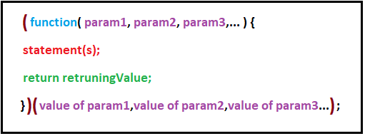

**Example 1:** on a function without parameters, without returning value.

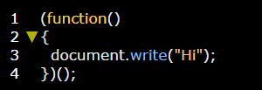

**Example 2:** on a function with parameters, with returning value.

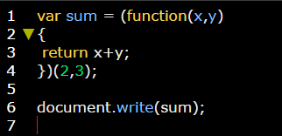

**Example 3:**

